Question 1:

1. 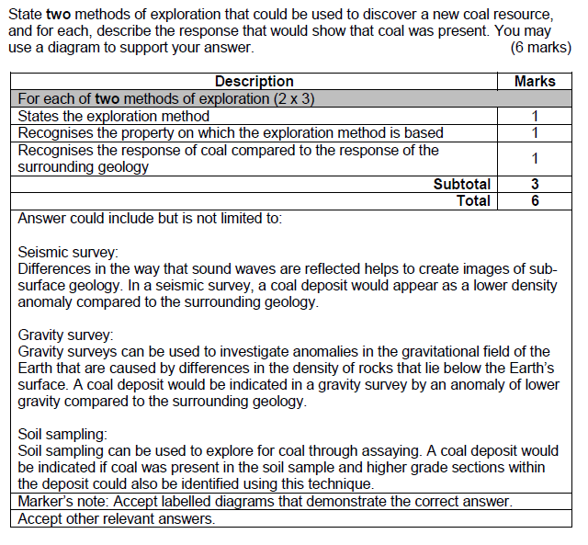

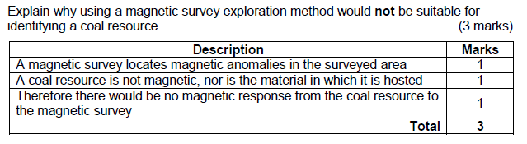

Questions 2. Surface mining (4 marks)

* Involves the removal of plant life and topsoil in order to access shallow deposits as cheaply as possible.
* The resource needs to be close to the surface
* Resource deposit does not need to be a high grade
* Hole dug down in stages to make benches, this adds stability and multiple places to excavate

Question 3. Underground mining (4 marks)

* When deep underground, vertical shafts are dug in order to reach the resource deposit
* This can also be done when the resource is found in pockets rather than a single deposit
* Internal ramps can then be dug out in order to access different levels.
* More costly than surface mining, but there is less surface environmental impact

Question 4.

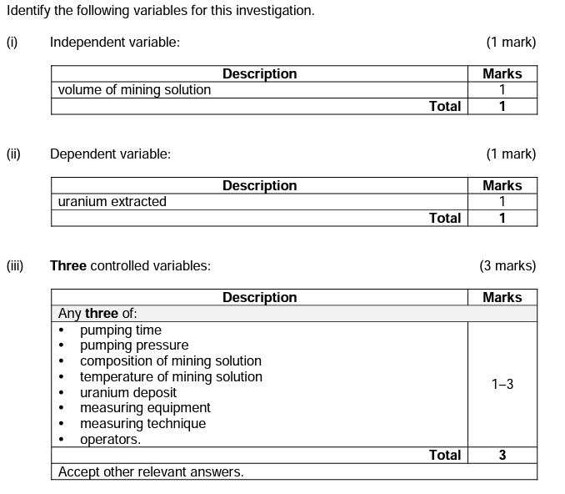

Question 5.

